SESSION 14 ASSIGNMENT 1

**Problem Statement:** Create a calculator to work with rational numbers.

Requirements:

○ It should provide capability to add, subtract, divide and multiply rational numbers.

○ Create a method to compute GCD (this will come in handy during operations on rational).

Add option to work with whole numbers which are also rational numbers i.e. (n/1)

-> achieve the above using auxiliary constructors.

-> enable method overloading to enable each function to work with numbers and rational.

**Solution:**

Firstly according to the requirement we will create class Calculator taking two integer parameters. We will be using Auxiliary constructor, so that if we are working with integer, the other will be passed as 1. The class will by default return a rational number. This rational number will then be passed to different methods such as add, subtract, multiply and divide.

class Calculator(a:Int, b:Int) {

def numer = a

def denom = b

def this(a:Int) = this(a,1)

def add(that : Calculator) = new Calculator(

numer * that.denom + that.numer * denom,

denom * that.denom

)

def sub(that : Calculator) = new Calculator(

numer * that.denom - that.numer * denom,

denom * that.denom

)

def mult(that : Calculator) = new Calculator(

numer * that.numer,

denom * that.denom

)

def divide(that : Calculator) = new Calculator(

numer * that.denom,

denom * that.numer

)

def gcd(a:Int, b:Int): Int = {

if(b == 0) a else gcd(b,a%b)

}

override def toString = numer + "/" + denom

}

Now, creating a method Options which will take user input and will be repeating until, user exits.Now, creating two if blocks one for operations with rational number and one with natural numbers.

Then two methods for computing different operations as entered by user, one for rational numbers and other for natural numbers.

object RationalMai {

def Options() = {

var input1 =0

var input2 = 0

var input3 = 0

var input4 = 0

var input5 = 0

do {

println("1. Add rational numbers")

println("2. Subtract rational numbers")

println("3. Multiply rational numbers")

println("4. Divide rational numbers")

println("5. Add numbers")

println("6. Subtract numbers")

println("7. Multiply numbers")

println("8. Divide numbers")

println("9. GCD of numbers")

println("10. Exit")

println("Enter any the option")

input1 = scala.io.StdIn.readInt()

}while(input1 < 1 && input1 > 9)

if(input1 == 10){

println("Bye")

System.exit(404)

}

//For rational numbers

if(input1 >=1 && input1 <=4) {

println("Enter the numerator of first rational")

input2 = scala.io.StdIn.readInt()

println("Enter the denominator of first rational")

input3 = scala.io.StdIn.readInt()

println("Enter the numerator of second rational")

input4 = scala.io.StdIn.readInt()

println("Enter the denominator of second rational")

input5 = scala.io.StdIn.readInt()

compute(input1, input2, input3, input4, input5)

}

//For natural numbers

if(input1 >=5 && input1 <=9) {

println("Enter first number")

input2 = scala.io.StdIn.readInt()

println("Enter second number")

input3 = scala.io.StdIn.readInt()

compute(input1, input2, input3)

}

}

def compute(input1:Int,input2:Int,input3:Int,input4:Int,input5:Int):Unit = {

require(input3 !=0)

require(input5 !=0)

var x = new Calculator(input2, input3)

var y = new Calculator(input4, input5)

input1 match {

case 1 => println("sum of " + x + " and " + y + " is " + x.add(y))

case 2 => println("difference of " + x + " and " + y + " is " + x.sub(y))

case 3 => println("Multiplication of " + x + " and " + y + " is " + x.mult(y))

case 4 => println("Division of " + x + " and " + y + " is " + x.divide(y))

}

}

def compute(input1:Int,input2:Int,input3:Int):Unit = {

var x = new Calculator(input2)

var y = new Calculator(input3)

var cal = new Calculator(input2,input3)

input1 match {

case 5 => println("sum of " + x + " and " + y + " is " + x.add(y))

case 6 => println("difference of " + x + " and " + y + " is " + x.sub(y))

case 7 => println("Multiplication of " + x + " and " + y + " is " + x.mult(y))

case 8 => println("Division of " + x + " and " + y + " is " + x.divide(y))

case 9 => println("GCD of " + x + " and " + y + " is " + cal.gcd(input2,input3))

}

}

def main(args: Array[String]): Unit = {

var i=0

while (i==0){

Options()

}

}

}

**OUTPUT:**

**Addition of two rational numbers**

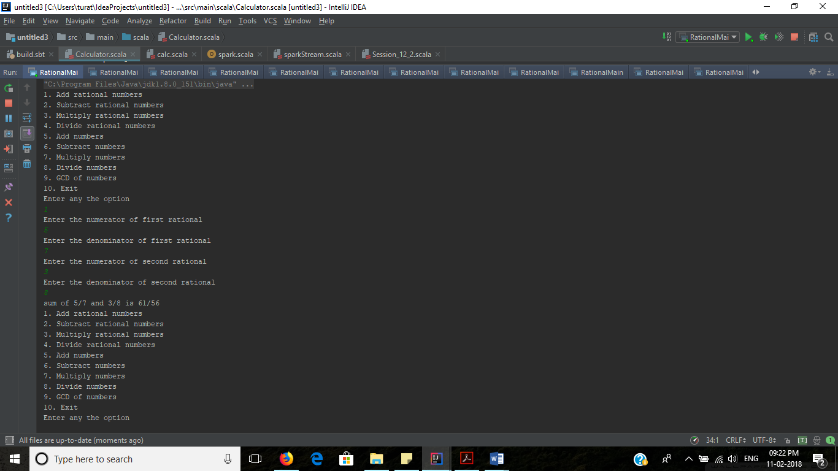

**Multiplication of two natural numbers:**

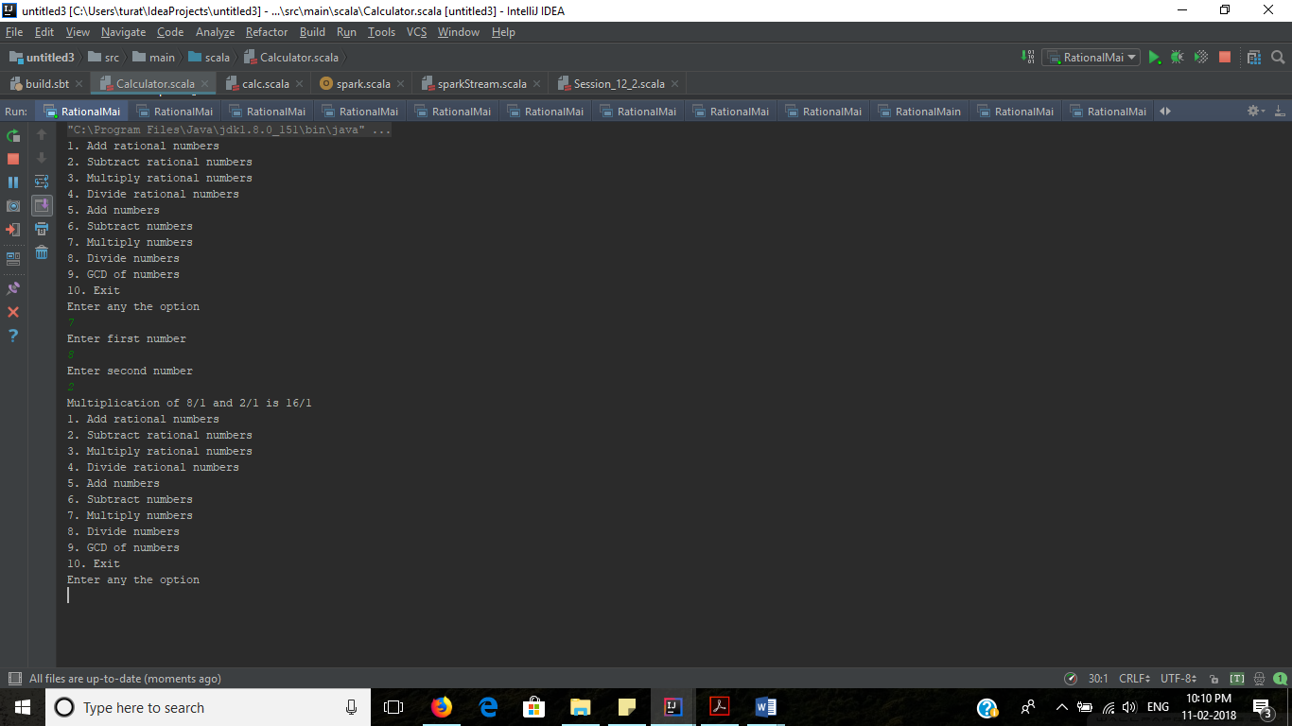

**Exit option:**

